The State Interagency team is pleased to announce that on April 29, 2016, the newly revised CANS training website www.canstraining.com will be ready for use. The CANS training website has been revised to make it easier for multiple providers throughout the children’s service systems to utilize the site’s tools, complete training and obtain certification necessary to be able to use the CANS-NY assessment tool.
All providers currently using the CANS-NY (OMH SED Waiver providers, OCFS B2H providers, NYC ACS foster care providers, SPOA, LGU) and those that will be new to the CANS (Health Home Care Managers starting October 2016) need to complete training and obtain certification in order to use the assessment.
Only one version of the CANS-NY training and certification (e.g., 2011 version, 2016 0-5 version or 2016 6-21 version) needs to be completed. If providers will be serving children/youth 0-21, you may be trained and certified in one age group’s tool but feel free to review the training of the other age group’s tool. There are some slight differences that providers should be aware of, but for purposes of certification completion of one tool’s training and testing is necessary. If selecting the 2016 versions (0-5 or 6-21), any one of the additional modules (e.g., Mental Health, Medical Health) may be selected for being certified in the CANS-NY. Certification is valid for one year, and each year staff and supervisors need to complete recertification. Follow the instructions below:
- Go to www.canstraining.com in navigation bar:
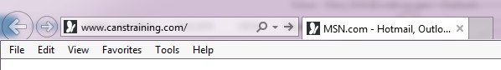
- If you are OMH HCBS waiver or SPOA or other OMH programs, you should double click on the CANS-NY 2011:
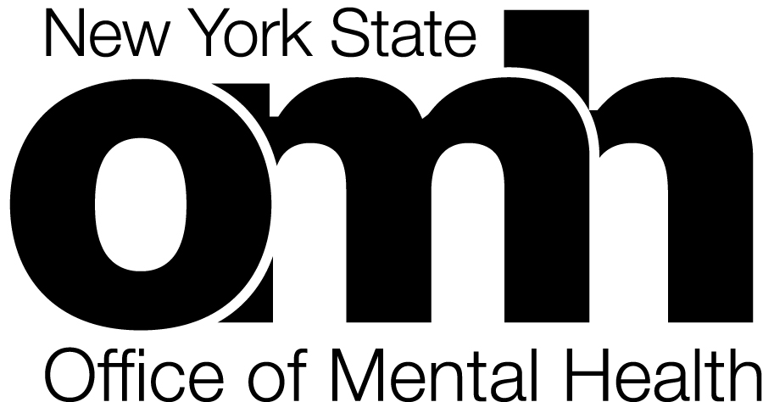pp

CANS-NY 2011 Training, Testing and Certification
OMH HCBS waiver and SPOA or other OMH programs

OR

If you are a Foster Care Agency in NYC working with Administration for Children’s Services (ACS), you should double click on CANS-NY 2011:
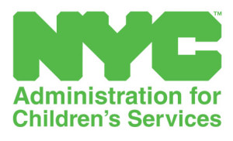

CANS-NY 2011 Training, Testing and Certification
Administration for Children’s Services (ACS) NYC

OR
If you are a Health Home Care Manager or Bridges to Health (B2H) provider, you should double click on either a blue (0-5 CANS-NY) or green (6-21 CANS-NY) icon based on tool for age of the child you will be working with. If providers will be serving children/youth 0-21, you may be trained and certified in one age group’s tool but feel free to review the training of the other age group’s tool. There are some slight differences that providers should be aware of, but for purposes of certification completion of one tool’s training and testing is necessary. In addition to selecting the age group most relevant to you, select the version that has the Additional Module that is most relevant. For example: if you primarily serve medically fragile children that are 6-21, choose a green icon with “MEDICAL HEALTH” in title.

Blue = 0-5 and Green = 6-21
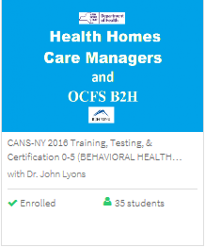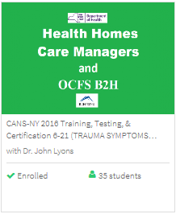
Additional module
Title
Age Group
Icon
Program Area

- After double clicking on the selected icon, you will see the Outline and Details page for instructions directing you to training and testing. You must go through all parts of the training before completing the test for certification. You may come back to the training in multiple sessions in addition to taking the test at a later time.
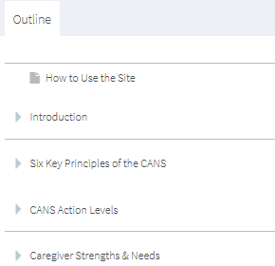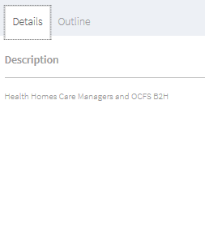
- After completing testing and scoring 70% or better, you will be certified for CANS-NY use. If you are a supervisor, your test score must be 80% or higher.

